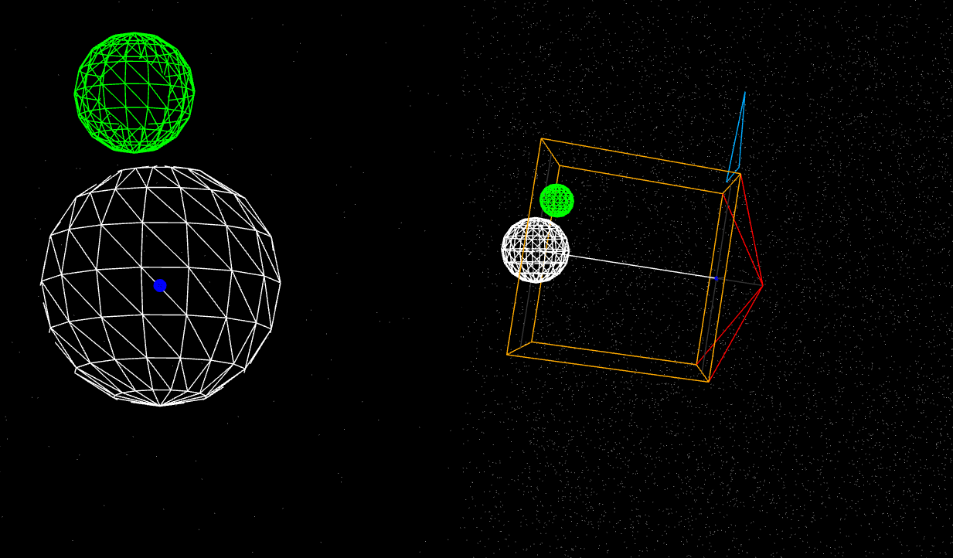

In the orthographic view, the perspective remains constant.

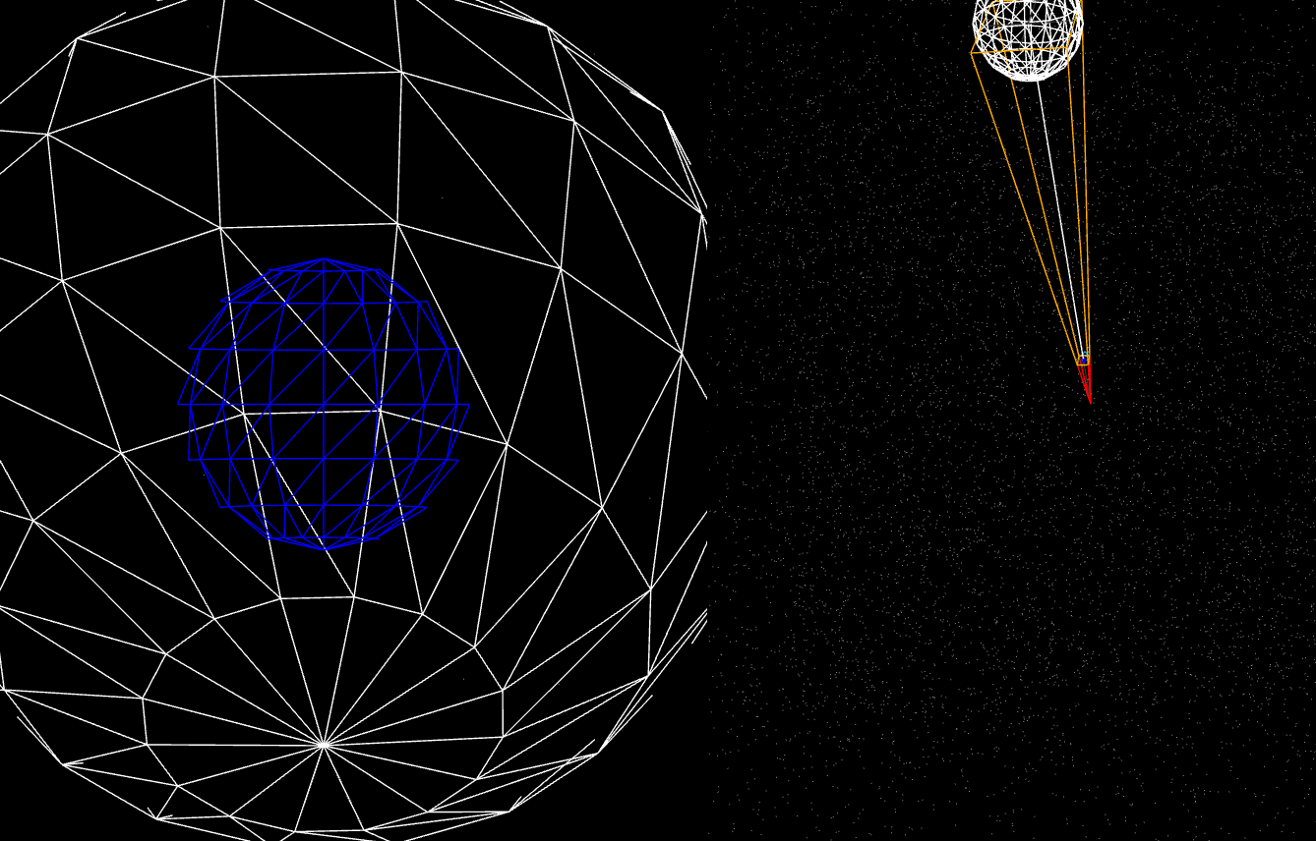

In the natural perspective view, the field of view acts as a main factor that modifies the objects that are being viewed by the viewer.

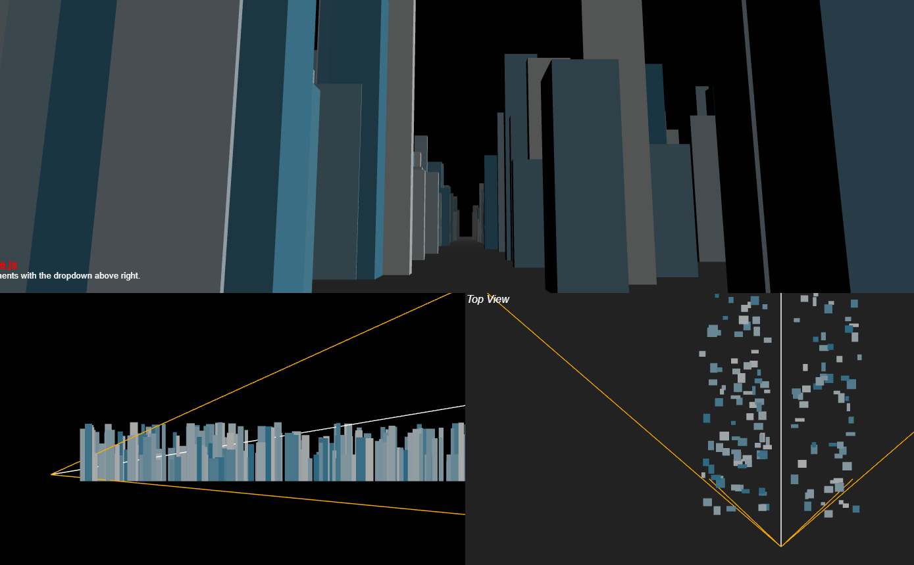

Tilt: The position of the camera appears to be at the bottom, pointing at the top. From this it can be seen that the camera is looking at the top of the “buildings”. The view volume reduces as the perspective points uypward.

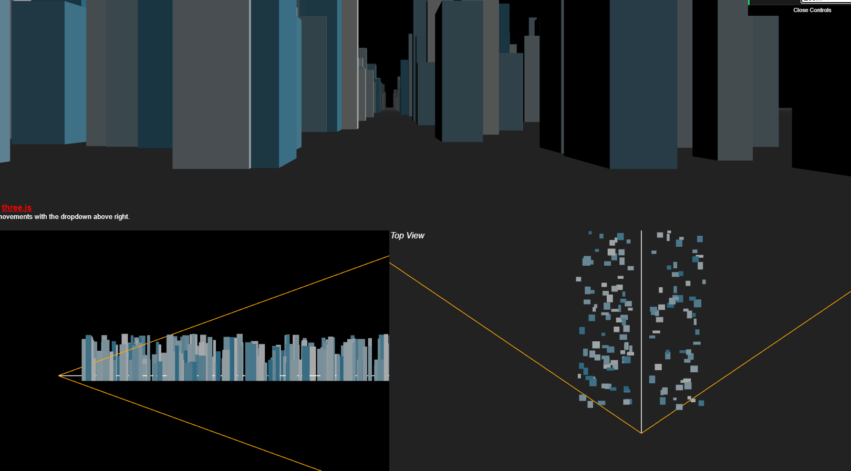

Zoom: The perspective of the camera appears to be stationary. It does pan in either more or less volume for the viewer to observe.

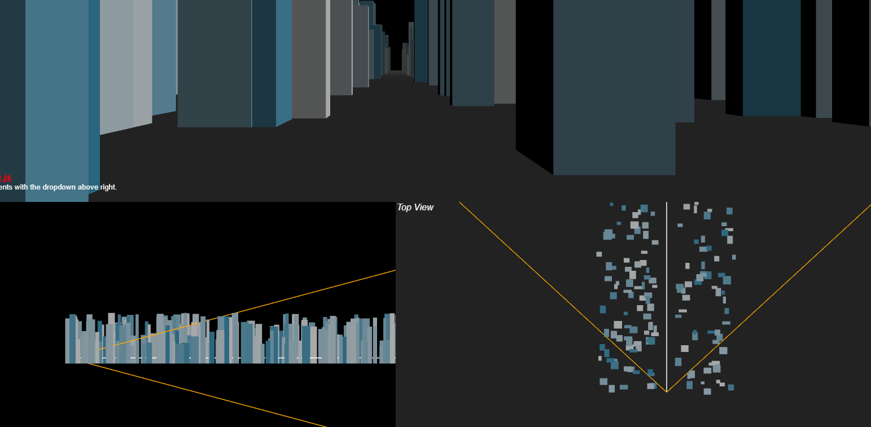

Dolly: The perspective appears to be going into the object. Looking at the top view, there appears to be more volume in the perspective view as the viewer goes into the object.